SCHOOL INTERVIEW/DISCUSSION GUIDE

Name of school: Mpungwe seed secondary school

1a | Does the Facility have a record of all assets provided under UgIFT.  (Obtain a record and verify if it has the costs and numbers supplied | - NO
1b | If Not ask how many were supplied and when. | - They have none because they are new staf

2 | How does this facility Maintain (repair/service/replace) the assets provided under Ugift  - It is maintained by the facility officials in charge using part of the PTA and Capitation grant to work on minor repair, service and replacement. For example because of UNEB, we forced to hire tents to accommodate the senior ones and two. We have replaced the desks with the single seat desks required by the UNEB standards.

3 | Does the facility take regular record about functionality/ or breakdown of the assets provided?  Nonfunctional/ working, and reasons for non-functionality. | - Yes  REASONS FOR NON FUNCTIONALITY  - Theft of school property due to lack of a fence  - Unreliable electricity  - Some equipment we received are substandard for examples the shelves, chairs, and desks

4 | How has the UgIFT support helped in service delivery in the area, any issues, challenges and any recommendations for better program implementation. | ISSUES/CHALLENGES  - High teacher to student ratio. The agreed ratio is 1:60 but the current follow up at Mpungwe seed shows a ratio of 1:100 . This will not be the ideal for the competency based curriculum.  - Inadequate classrooms. Class rooms are very few compared to learners for example during UNEB time, the school hires tents and chairs to accommodate S.1 and S.2 students hence making learning very difficult and uncondusive.  - Inadequate supervision structure. The inspection of schools is primarily handled by primary based inspectors who are assigned to supervise secondary schools. This leads to supervision of areas they are not trained in hence gaps in effective quality assurance and support for secondary schools.  - Inadequate teachers. Teaching staff is insufficient at the facility and even when efforts are made to lobby for more staff from the government, we are hampered by lack of wage provision. Even those teachers that are available at school eg agriculture, PE, English, Math are diploma level and they teach both A and O level.  - Inadequate support staff. The facility is really overstretched handling non-teaching roles because it doesn’t have a nurse, librarian, cleaners and a secretary. etc.  - Safety at school. The school is always facing the challenge of school property mainly because if lack of fence  RECOMMENDATIONS  - The government should recruit and deploy more teachers to the school and provide wage to reduce the ratio from 1:100 to the recommended 1:60 for effective CBC implementation  - The ministry should deploy secondary specialized inspectors of school to supervise secondary schools for effective quality assurance  - The ministry should opt to recruit more non-teaching staff to relieve teachers and improve administration, hygiene and security.  - The ministry is urged to construct more staff quarters to retain teachers with in the school community.

PROCEED TO VERIFICATION AFTER THIS DISCUSSION

SCHOOL FURNITURE
(School Desks, Office chairs, Laboratory stools, Book shelves)

Name of LG Muyuge District Local Government Name of SCHOOL Mpungwe seed secondary school.

Equipment/ Item | Department | Item  Description | Life in Months | Tag Number ( engrave no.) | Date Of Pur | Date Placed In Service | Recoverable cost | Cost | Acc Dep Cost | Net Book Value | Ytd Deprn | Equipment status | Remarks
School Desks, | education | Long Brown wooden with black metallic stands and a shelve for books |  | engraved  (Mpungwe SS/001) |  |  |  |  |  |  |  | Good and in use | 116 verified as good then 4 damaged
Office Chairs | Education | Coffee brown soft seatr with 4 metallic black stands |  | engraved  (Mpungwe SEED SS/045) |  |  |  |  |  |  |  | functioning | Counted 21 and verified them
Laboratory stools | Education | Round wooden hard seat with 4 black metallic stands |  | engraved  (Mpungwe SS/065) |  |  |  |  |  |  |  | Good and in use  But some broken | 40 verified and in good use.  45 broken
Book shelves | education | Wooden in nature, wall mounted with gray metals while others are built on the wall with compatibles |  | Not engraved |  |  |  |  |  |  |  | Good condition | 47 shelves places in different blocks  verified
Leaners  Chair | education | Brown single sitter square woolen chair with 4 metallic |  | engraved |  |  |  |  |  |  |  | Most of them in  good condition  Very few damaged  and not in use | All 137  Verified as good  In use and 81  broken
drawers | education | Vertical wall cupboard built the the behind corner of the classroo |  | Not engraved |  |  |  |  |  |  |  | Good condition  And  functional | 6 built with each classroom one built and verified.
learners  table | education | Wide wooden brown table with metalic stands |  | engraved  (Mpungwe) SEED SS/007 |  |  |  |  |  |  |  | Good condition  And  functional | Verified  76 good and in use  10 demaged,
office  table | education | Wide wooden brown table with a cabinet |  | engraved  (Mpungwe) SEED SS/010 |  |  |  |  |  |  |  | Good condition  And  functional | Verified  5 good and in use
ICT ITEMS TO VERIFY
(Desktop Computer, Server Processor, Network Switch 24 Port, Multipurpose Printer, UPS, Projector, Air Conditioners, Server, CCTV Camera)

Name of LGmuyuge District local government Name of SCHOOL Mpungwe seed secondary school.

Equipment/ Item | Department | Item  Description | Life in Months | Tag Number ( engrave no.) | Date Of Pur | Date Placed In Service | Recoverable cost | Cost | Acc Dep Cost | Net Book Value | Ytd Deprn | Equipment status | Remarks
Desktop Computer | Education | Intel core i5  Processor,  13th  Generation  RAM 8GB,  512SSD,  15 INCH |  |  |  |  |  |  |  |  |  | stolen | 20received but  not verified,focal person claim them lost
Server Processor | education |  |  |  |  |  |  |  |  |  |  | stolen | 1 received but  not verified,focal person claim them lost
Network Switch 24 Port | education | CORE L2  SWITCH  L3 IRU CHASSIS |  |  |  |  |  |  |  |  |  | stolen | 2 received but  not verified,focal person claim them lost
Multipurpose Printer | education | A4,LASER  33PPM  MINIMUM  1200*1200 |  |  |  |  |  |  |  |  |  | stolen | 1 received but  not verified,focal person claim them lost
UPS | education | AT LEAST  750VA  SWING AC  196-280V  50-60HZ |  |  |  |  |  |  |  |  |  | stolen | 20 received but  not verified,focal person claim them lost
Projector | education | 3LCD/DLP/  LED  TENONOLOGY |  |  |  |  |  |  |  |  |  | stolen | 1 received but  not verified,focal person claim them lost
Air Conditioners | education |  |  |  |  |  |  |  |  |  |  | stolen | 2received but  not verified,focal person claim them lost
Server | education | 12TH  GENERATION  DVD-ROM  9.5MM ODD |  |  |  |  |  |  |  |  |  | stolen | 1 eceived but  not verified,focal person claim them lost
CCTV Camera | education | 4MP  UP TO 30  IMAGES PER  SECOND |  |  |  |  |  |  |  |  |  | stolen | 1 eceived but  not verified,focal person claim them lost
firewall | education | VPN(SSL VPN  &IPSee) |  |  |  |  |  |  |  |  |  | stolen | 1 eceived but  not verified,focal person claim them lost
wireless  router | education | 2.4GHZ  5.0GHZ |  |  |  |  |  |  |  |  |  | stolen | 1 eceived but  not verified,focal person claim them lost
LAN

BUILDINGS TO VERIFY
(Non- Residential and Residential, Kitchen, Toilets/Pit latrine Water tanks, Fences etc.)

Name of LG muyuge District local government Name of SCHOOL Mpungwe seed secondary school

Equipment/ Item | Department | Asset Number | Item  Description | Life in Months | Tag Number ( engrave no.) | Date Of Pur | Date Placed In Service | Recoverable cost | Cost | Acc Dep Cost | Net Book Value | Ytd Deprn | Equipment status | Remarks
Classroom block | education |  | Coffee brown and yellow in color with white glasses and ventilators and a lightening conductor on top of the roof |  | Not engraved |  |  |  |  |  |  |  | All functioning | The following were verified.  3 classroom blocks with two partitions each.  1 main hall.  1 computer lab.  1 administration block  1 science lab
Fence | education |  |  |  |  |  |  |  |  |  |  |  | Not yet built | Not verified
latrines | education |  | Colored coffee brown with a private wall with 5 stances |  | Not engraved |  |  |  |  |  |  |  | functioning | 6 seen verified.  1 for boys.  1 for girls.  1 for staff.
Water tanks | education |  | Black in color, cylindrical in nature, put on the raised base |  | Not engraved |  |  |  |  |  |  |  | All functioning | 2 were verified.  1 on the administration block  1 on the lab.  1 on the classroom block
Kitchen Block | education |  | Coffee brown and yellow in color with a smoke outlet |  | Not engraved |  |  |  |  |  |  |  | Not yet buil | Not verified
Lightening conductor | Education |  | Metallic in nature, put on top of the roof running downwards to the ground |  | Not engraved |  |  |  |  |  |  |  | functioning | Counted and verified 14
staff  quarters |  |  | Coffee brown and yellow in color with each 4units |  | Not engraved |  |  |  |  |  |  |  | Good condition and functional | 3 received,  verified  In use
staff  kitchen |  |  | Coffee brown and yellow in color with a smoke outlet and 2 uits |  | Not engraved |  |  |  |  |  |  |  | Good condition and functional | 3 received,  verified  In use
staff  latrines |  |  | Colored coffee brown with a private wall with 2 stances and 2 bathrooms. |  | Not engraved |  |  |  |  |  |  |  | Good condition and functional | 1 received and verified, in use
staff  water  tank |  |  | Black in color, cylindrical in nature, put on the raised base |  | Not engraved |  |  |  |  |  |  |  | Good condition and functional | 1 received and verified, in use

ASSET VERIFICATION BRIEF REPORT
MPUNGWE SEED SECONDARY SCHOOL

DATE 24TH/8/2026.

CONDUCTED BY WANDERA SOLOMON AND KIYUBA SALIMU

Introduction.
This brief report presents the findings of the physical asset verification exercise conducted at mpungwe seed secondary school on 26TH/8/2026. The team was warmly welcomed by respondent, the depute headmistress who was the focal person in this exercise .

Findings.
- Key assets including all furniture and buildings were physically verified and found present. However, the computer laboratory was not verified with claims that it was lobbed and all the ICT equipment were stolen and case is in court said the depute headmistress who was the focal person in this verification exercise . All the items were found to be functional and in good physical condition. However,
- Limited infrastructure. The facility is facing a challenge of inadequate facilities for studies. This has led to congestion, during UNEB we rent tents to accommodate the senior ones and twos said deputy headmistress
- The facility has inadequate accommodation for staff. The available staff quarters are not sufficient to accommodate all the critical staff required to be within the facility premises especially the principals.
- The facility lacks non staffing such as library attendant, cleaners, cooks and also the facility lacks a fence hence making liable to theft.

Challenges.
- Almost all the assets were not engraved thus making the verification exercise very hard because we could not establish whether what we verified was for Gift of not.
- Some offices including administration and computer lab were inaccessible at the time of visit due to lack of keys since the keepers were not available at the time of verification.
- The district failed to give us the asset register and the DEO only provided for ICT, therefore, we only relied on the physical counting.

Recommendation.
- Management should provide a police report or an official document for the reported theft of the ICT lab for accountability. The ministry through the district should consider re equipping the computer laboratory and strengthening security
- The ministry through the district should prioritize at expanding classroom or infrastructure to reduce congestion. Temporary renting of tents during UNEB should be addressed by constructing more examination halls.
- Limit the supply of many equipment and ensure needs based supply. The supply of equipment should be based on facility needs assessment and capacity.
- Immediate engraving of assets should be done immediately upon receipt with source of funding and asset codes for easy identification during verification.
- On staffing and security, the ministry through the district should recruit more teaching, non-teaching to ensure effective and quality education.
- The district and DEO should always maintain and provide an update asset register during the verification.
- Ministry through the district should consider construction of more staff quarters to accommodate and retain critical staff for effective teaching.

Conclusion.
The asset verification exercise was successfully completed with full staff from depute headmistress. All critical assets were verified, are functional, in good condition and well-handled apart from a very few cases of broken furniture.
Addressing non-teaching staff and staff accommodation, fence and kitchen challenges will greatly improve on the quality, efficiency and asset management.

Annex

Physical Verification Pictures.

The table below illustrates some physical status of the verified assets with photographic evidence.
Physical verification photos
MPUNGWE SEED SECONDARY SCHOOL | 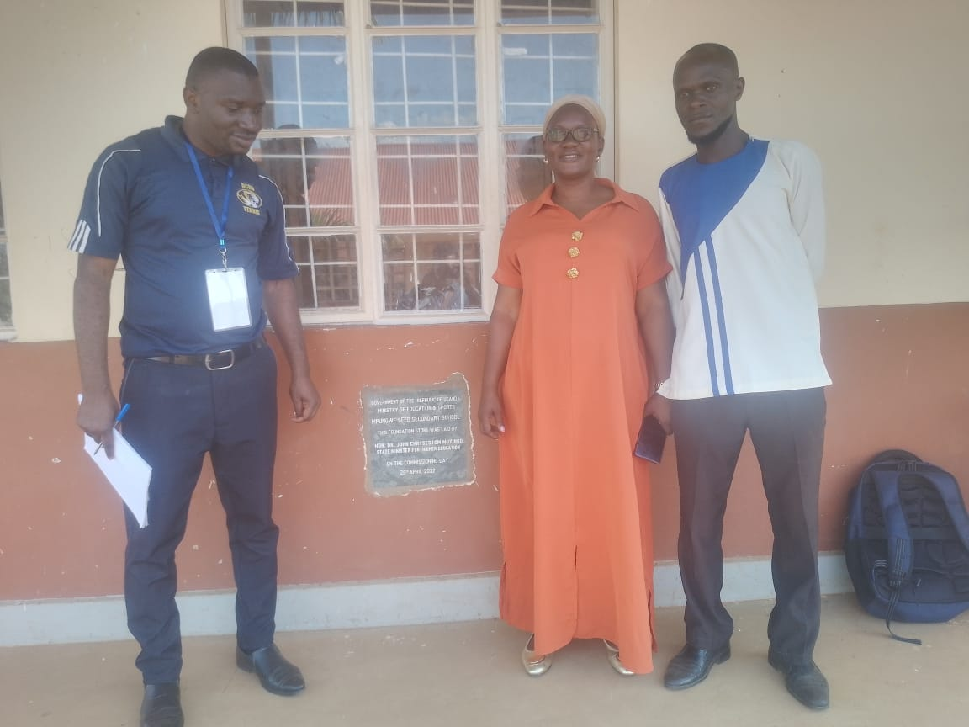

MPUNGWE SEED SECONDARY SCHOOL  LAB | 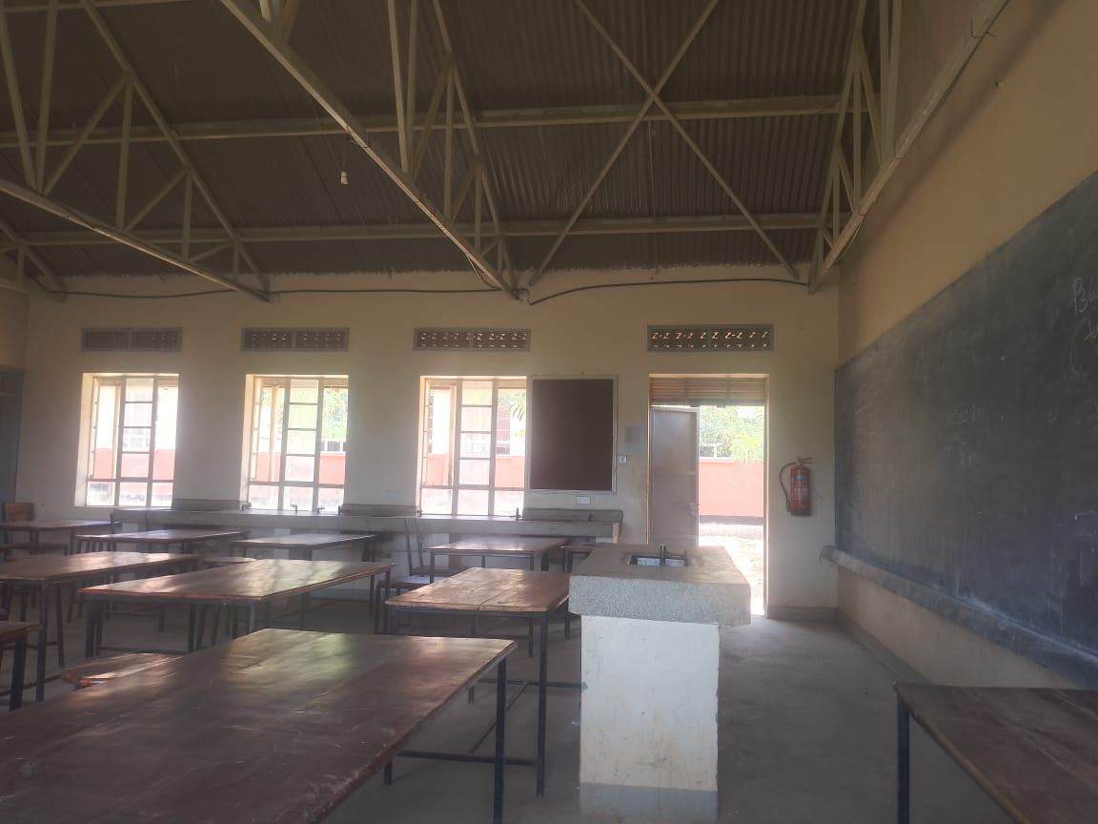

MPUNGWE SEED SECONDARY SCHOOL  BROKEN STOOL AND LEARNERS CHAIR WELL ENGRAVED  (MPUNGWE SEED SS/276) | 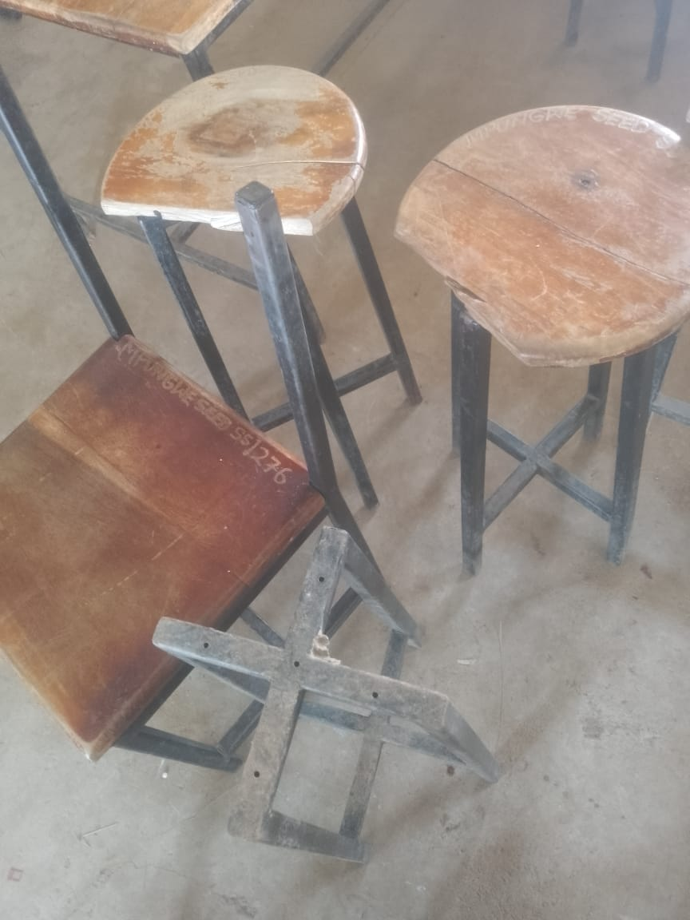
MPUNGWE SEED SECONDARY SCHOOL  LEARNERS CHAIR. | 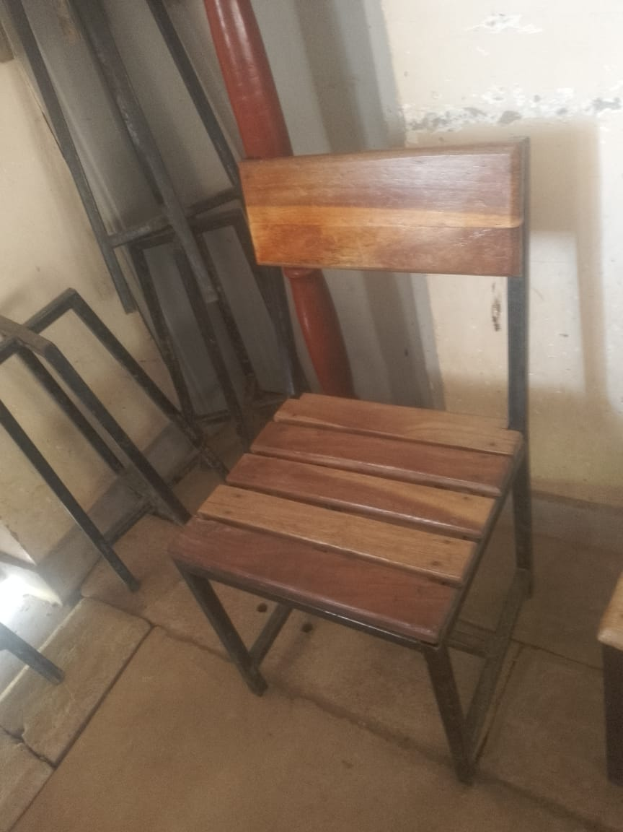
MPUNGWE SEED SECONDARY SCHOOL  OFFICE CHAIR. | 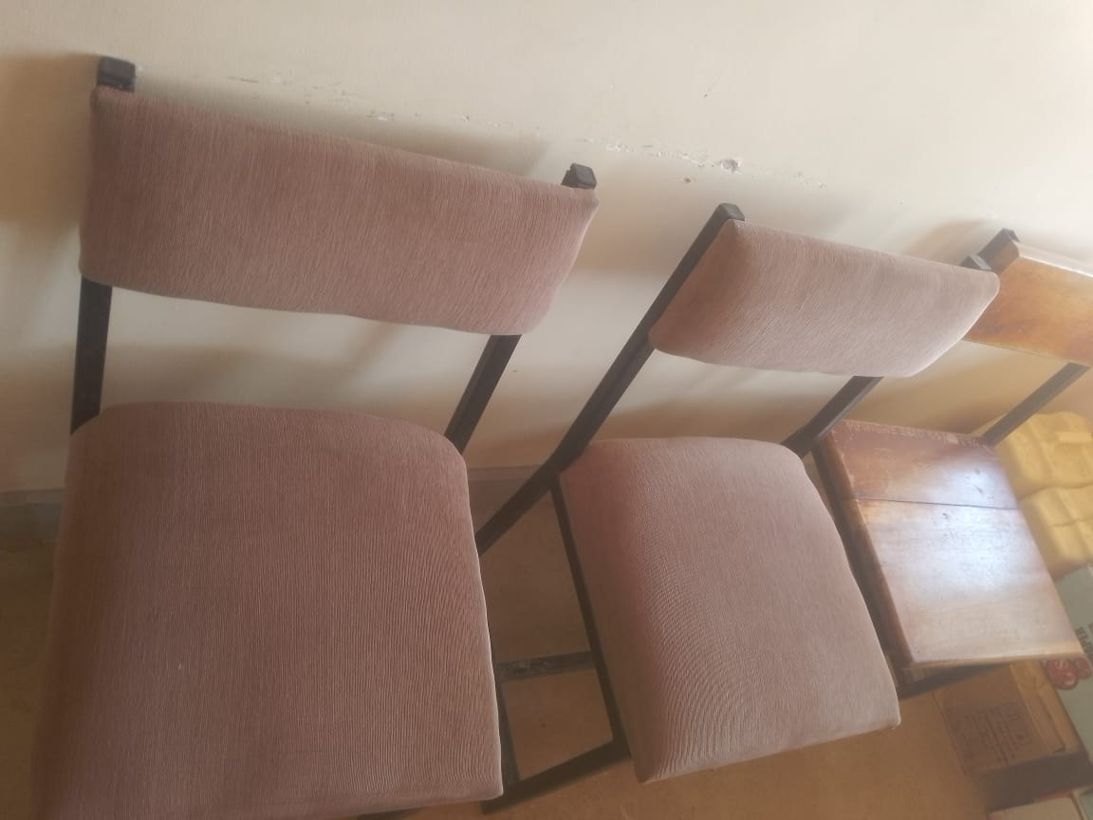
MPUNGWE SEED SECONDARY SCHOOL  COMPUTER LAB AND LIBRARY. | 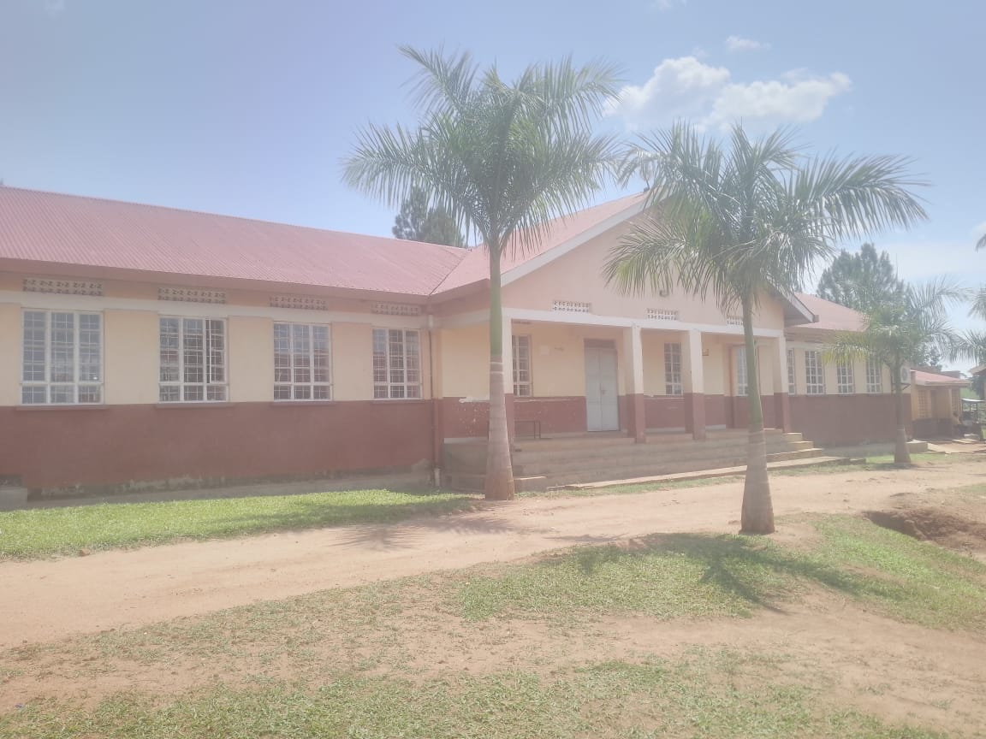
MPUNGWE SEED SECONDARY SCHOOL  LEARNERS TABLE  ENGRAVED. | 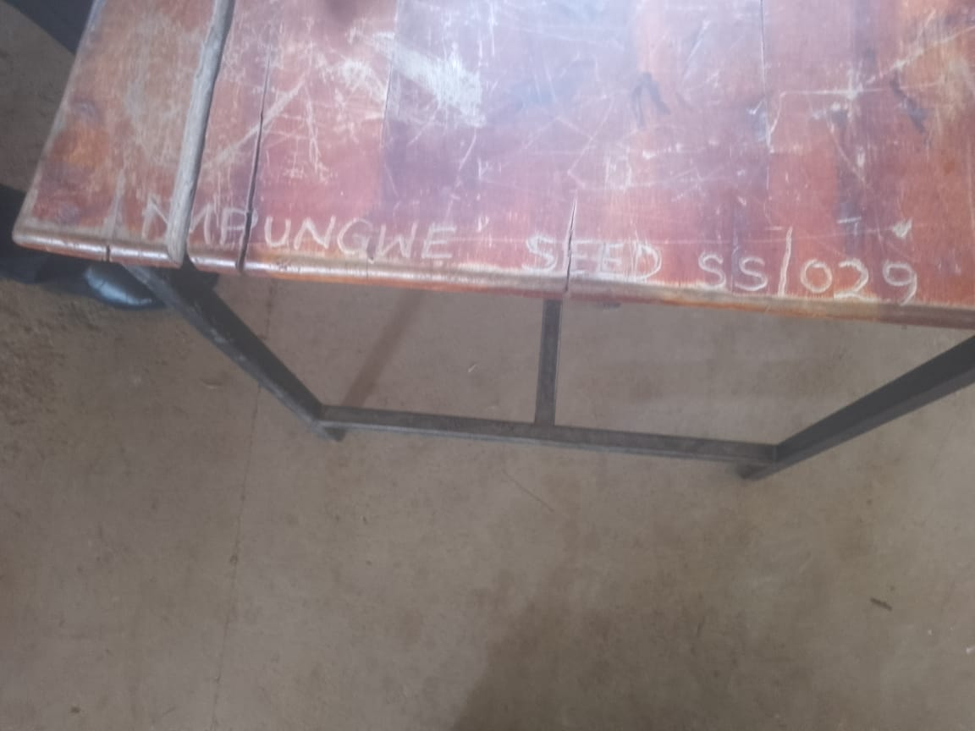
MPUNGWE SEED SECONDARY SCHOOL  LEARNERS DESK  AND BOOK SELVES | 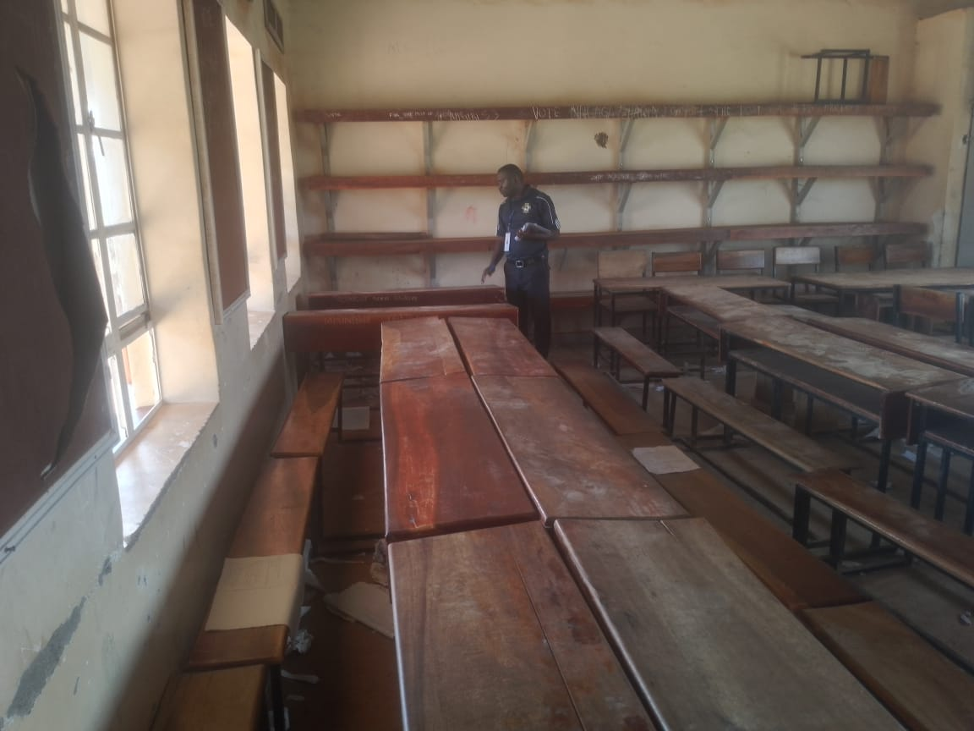
MPUNGWE SEED SECONDARY SCHOOL  OFFICE TABLE | 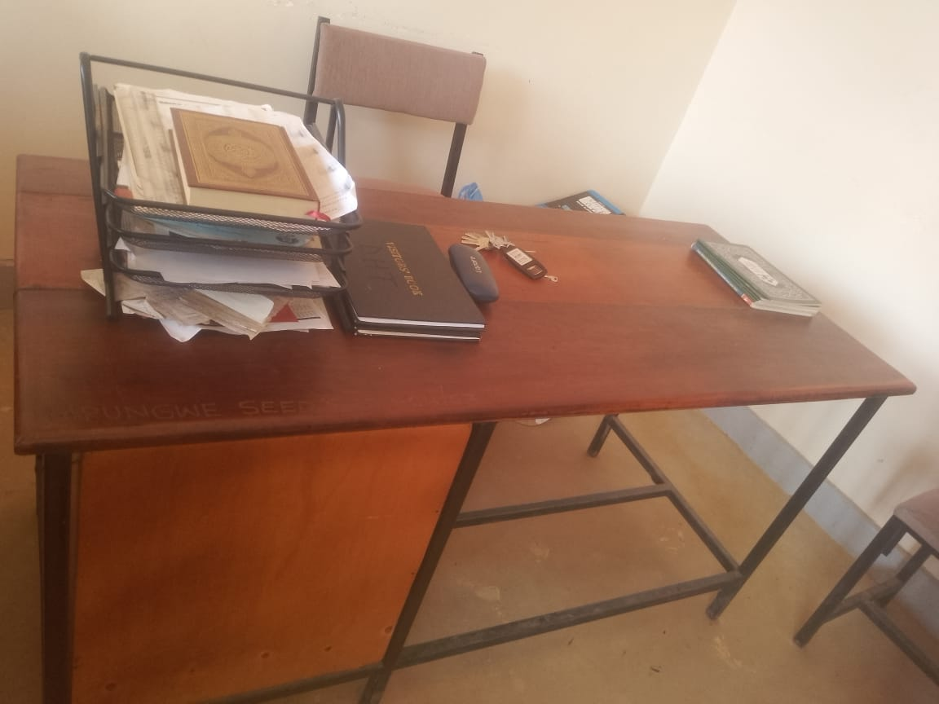
MPUNGWE SEED SECONDARY SCHOOL  LEARNERS  TABLES | 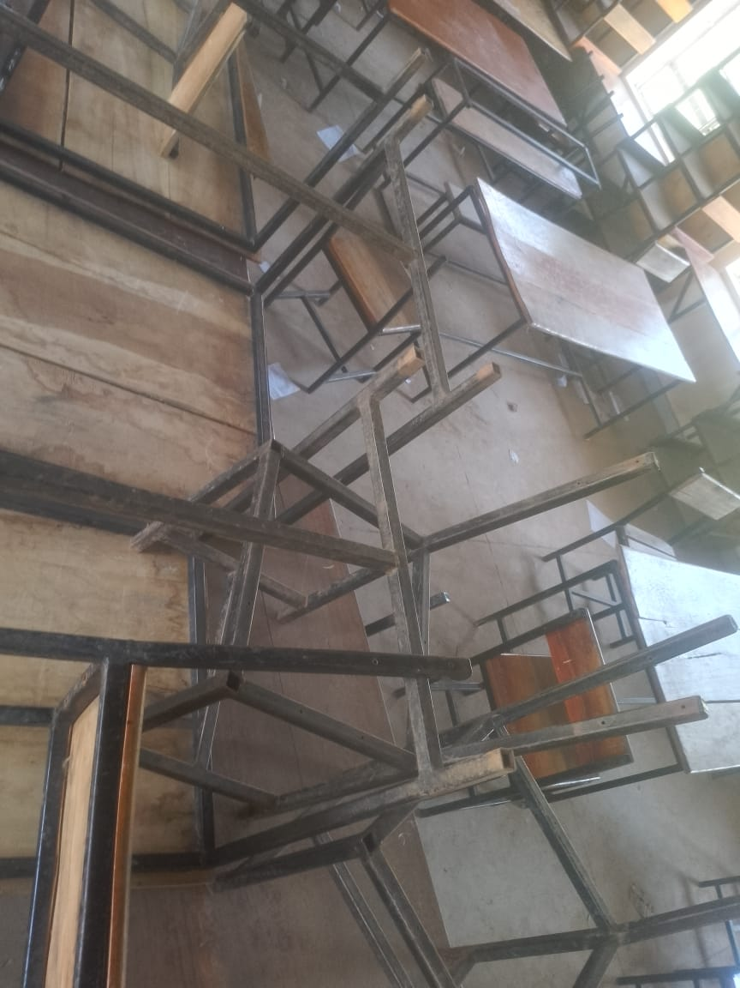
MPUNGWE SEED SECONDARY SCHOOL  WALL BUILT DROWER/CUPBOARD | 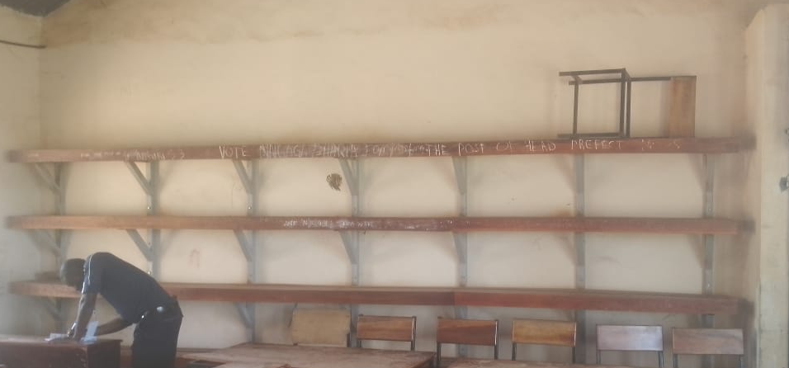
MPUNGWE SEED SECONDARY SCHOOL  CLASSROOM BLOCK | 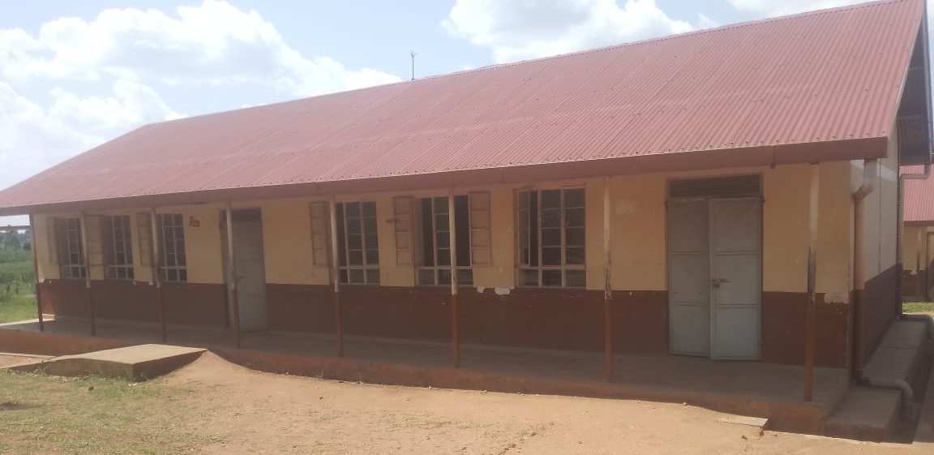
MPUNGWE SEED SECONDARY SCHOOL  STAFF QUARTER | 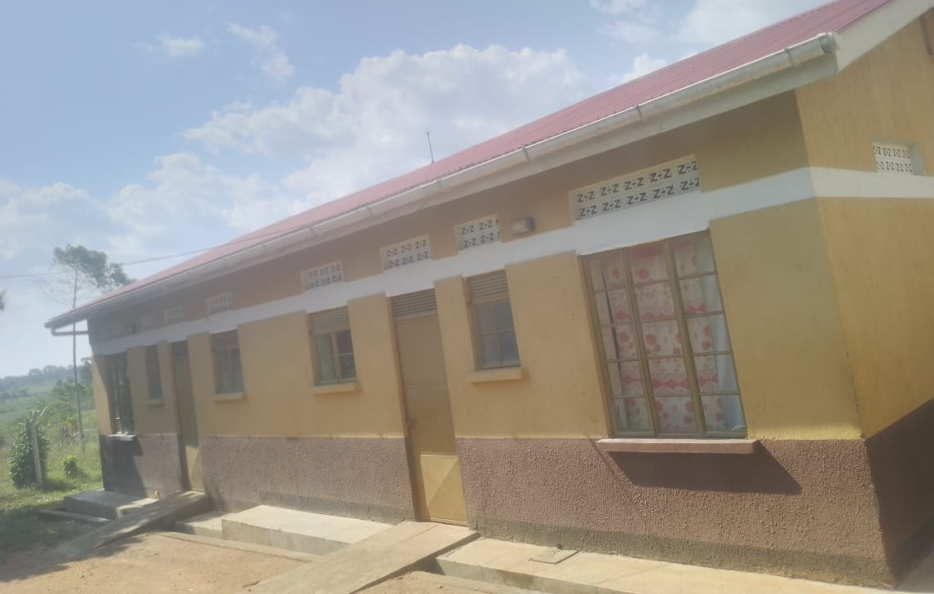
MPUNGWE SEED SECONDARY SCHOOL  LEARNERS LATRINE | 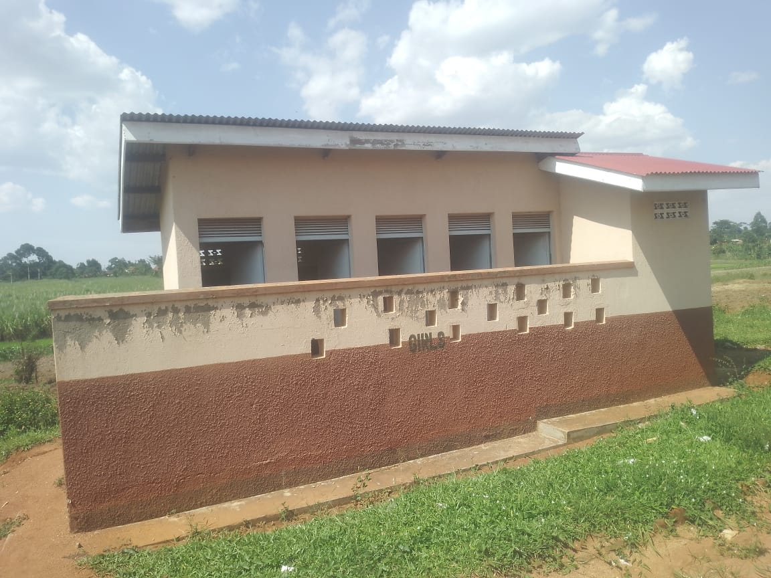
MPUNGWE SEED SECONDARY SCHOOL  INTERIOR CLASSROOM. | 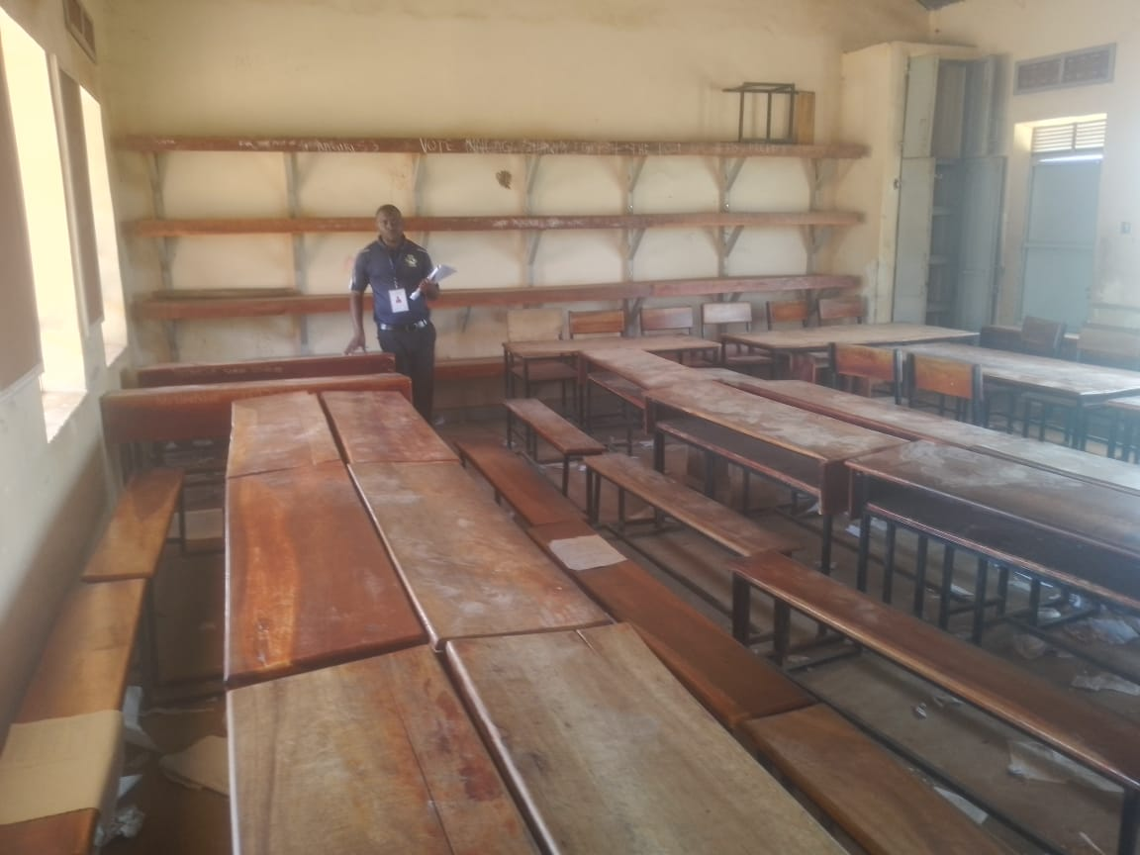
MPUNGWE SEED SECONDARY SCHOOL  SCIENCE LAB. | 